Scene

📘 Definition
# Source: AI Source: Provided by: [Data Path: Persons Table -> ID Column: 1, Name_En Column: Motasem Essam] -> From: [ChatGPT] on [5/2/2026]
A scene is the complete arrangement of all objects, lights, cameras, and environments in a 3D space at a specific moment. It is like a full “setup” that the computer renders to create an image or animation.

🎬 What a scene includes
# Source: AI Source: Provided by: [Data Path: Persons Table -> ID Column: 1, Name_En Column: Motasem Essam] -> From: [ChatGPT] on [5/2/2026]
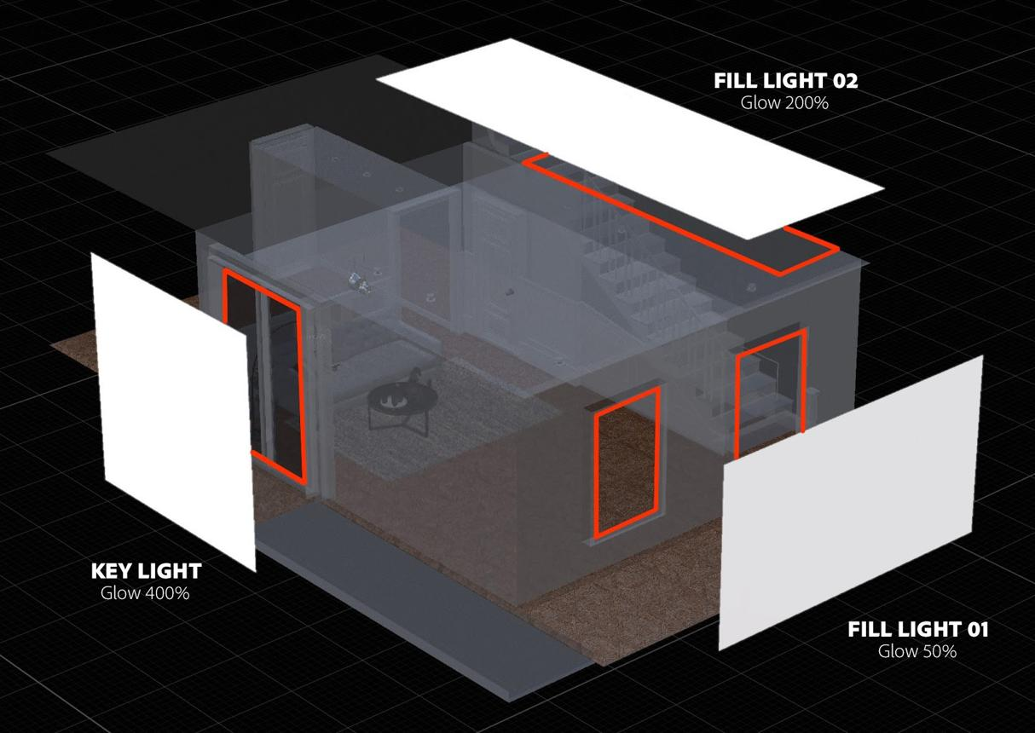
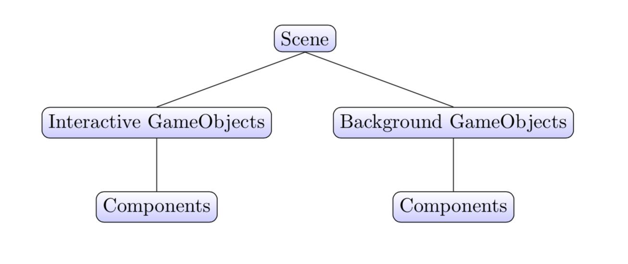
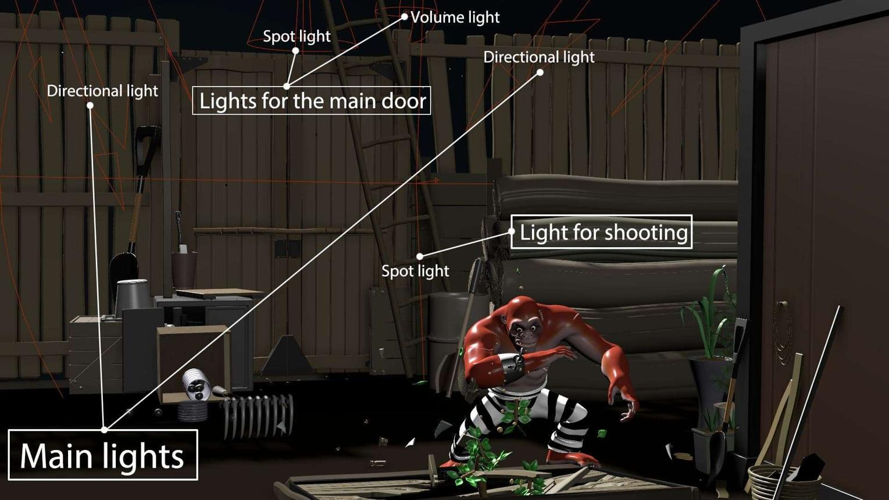
A typical scene contains:
- 🧊 Objects/Models → characters, buildings, props
- 💡 Lights → point, directional, spot, ambient
- 📷 Camera → viewpoint of the scene
- 🌍 Environment → background, sky, terrain
- 🎨 Materials & textures → surface appearance

🧠 Simple example
# Source: AI Source: Provided by: [Data Path: Persons Table -> ID Column: 1, Name_En Column: Motasem Essam] -> From: [ChatGPT] on [5/2/2026]
Think of:
- 🎬 A movie set → actors, lights, camera, background
- 🎮 A video game level → world, enemies, items, lighting
Everything together forms a scene.

🎮 Scene in computer graphics
# Source: AI Source: Provided by: [Data Path: Persons Table -> ID Column: 1, Name_En Column: Motasem Essam] -> From: [ChatGPT] on [5/2/2026]
Scenes are used to:
- Build 3D worlds in games and movies
- Organize all visual elements in one space
- Control how the final image or animation looks
- Render frames for animation or gameplay

⚙️ Key features
# Source: AI Source: Provided by: [Data Path: Persons Table -> ID Column: 1, Name_En Column: Motasem Essam] -> From: [ChatGPT] on [5/2/2026]
- 🧩 Combines all visual elements together
- 📷 Has a defined camera viewpoint
- 💡 Includes lighting and environment
- 🎬 Used to generate final images or animations

🚀 In short:
# Source: AI Source: Provided by: [Data Path: Persons Table -> ID Column: 1, Name_En Column: Motasem Essam] -> From: [ChatGPT] on [5/2/2026]
Scene = the complete setup of objects, lights, camera, and environment used to create a final image or animation in computer graphics.

